# Project: Resident Evil

Resident Evil is a system that registers virus spreads across the world. It is a significantly big project, and as such it will have several parts. In this exercise you will land the basis of the application. You will also create the majority of the visual design.

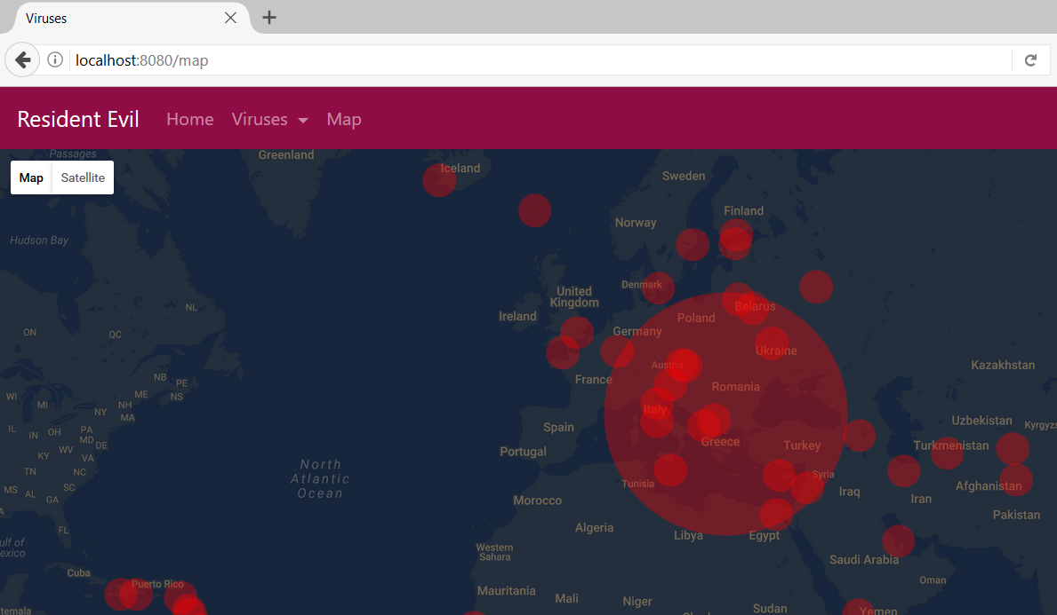

# Exercises: Thymeleaf Engine

Problems for exercises and homework for the [“Java MVC Frameworks - Spring” course @ SoftUni](https://softuni.bg/trainings/1538/java-mvc-frameworks-spring-march-2017).

## Views

You would need couple of views. Separate the **menu and the forms** in html files and include them. Use a design that you find appropriate. The examples use **Bootstrap 4**.

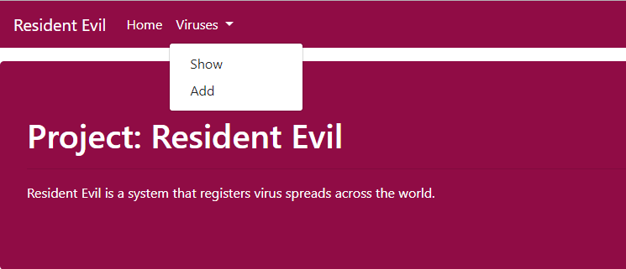

* **Home**
  + Entry point of the application
* **Viruses**
  + Dropdown menu with 2 buttons – [Show] and [Add]
  + [Show] – All the viruses are shown here. You can **edit** and **delete** each virus.
  + [Add] – You can add.

**NOTE:** #900C45 this is the color you need ☺

## Data Entities

Create the required **entities**. Use the appropriate **data types**.

* **Virus**
  + Name – Cannot be empty, should be between **3** and **10** symbols.
  + Description – Cannot be empty, should be between **5** and **100** symbols.
    - Represented as Text in the database
  + Side Effects – Should have a maximum of **50** symbols.
  + Creator – Should be either Corp or corp.
  + Is Deadly – Boolean
  + Is Curable – Boolean
  + Mutation – Cannot be null. Should hold one of the following values:
    - ZOMBIE
    - T_078_TYRANT
    - GIANT_SPIDER
  + Turnover Rate – Number, between **0** and **100**.
  + Hours Until Turn (to a mutation) – Number, between **1** and **12**.
  + Magnitude – Cannot be null. Should hold one of the following values:
    - Low
    - Medium
    - High
  + Released On – Date, should be before the “today” date.
  + Capitals – A **collection** of Capitals.
* **Capitals**
  + Name
  + Latitude
  + Longitude

## Establish the Back-End

Create the required:

* **Entities**
* **Models**
* **Repositories**
* **Services**
* **Controllers**

**Load** the **capitals** by the provided **SQL.**

## Add Viruses

Create a functionality to **add** Viruses. Make the necessary **validations**. Create a custom annotation to validate the Release Date.

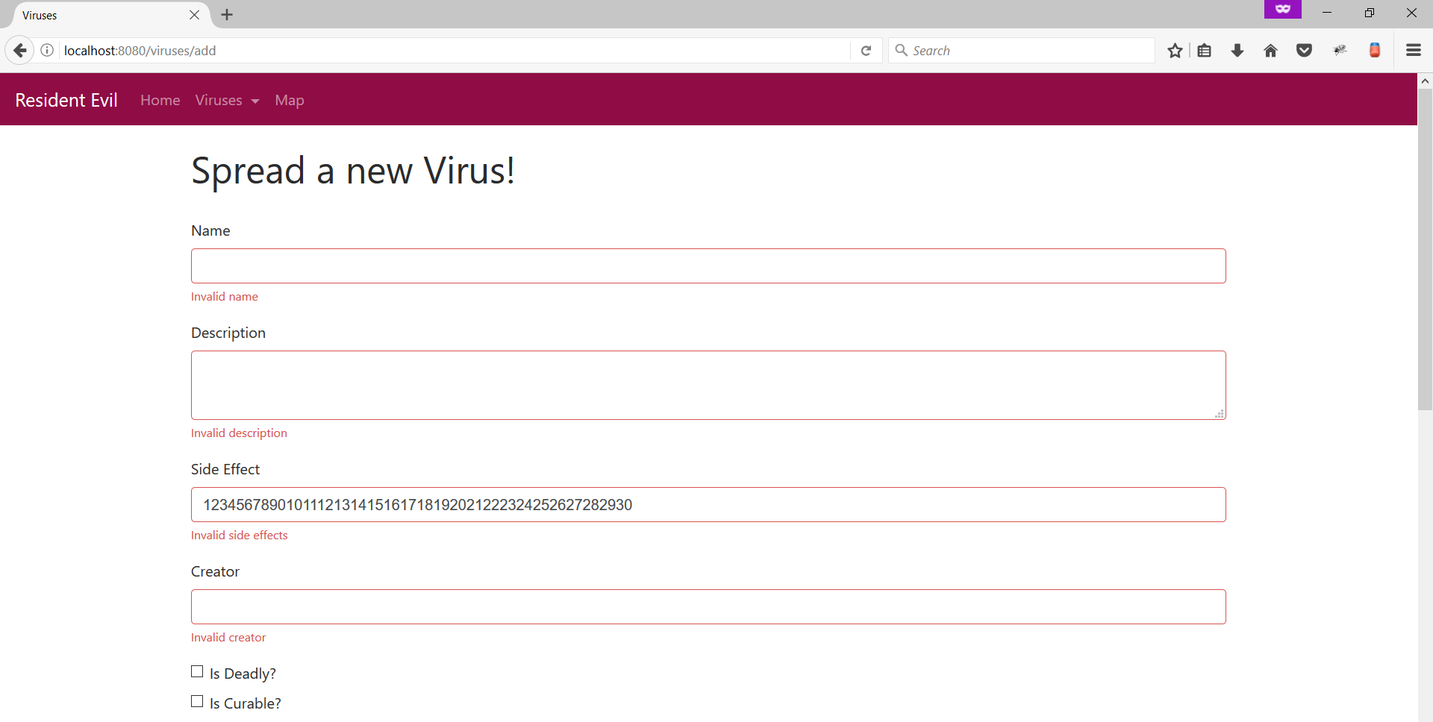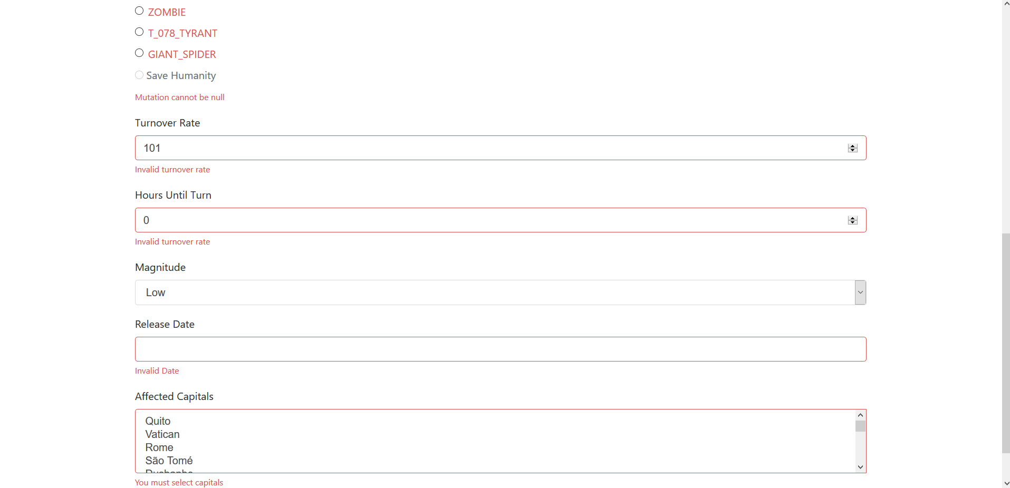

## Show Viruses

Create a functionality that **shows** all of the created viruses.

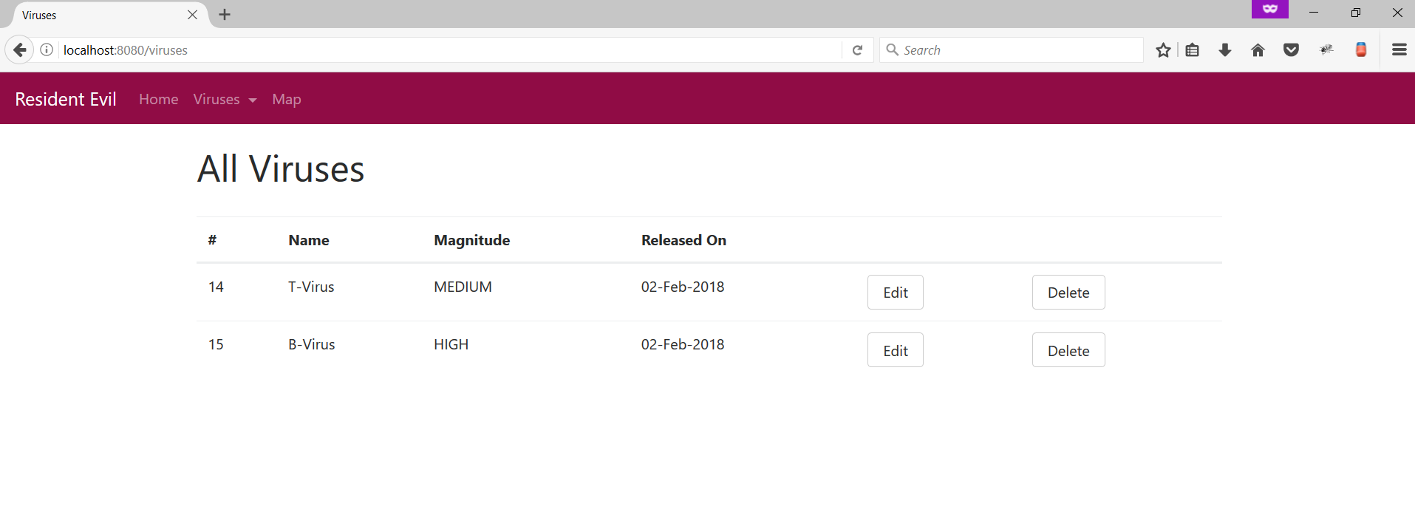

## Edit Viruses

Create a functionality to **edit** Viruses. You should be able to edit everything **except** the **release date**. Make the necessary **validations.**

## Delete Viruses

Create a functionality to **delete** Viruses